**LAB # 9**



**CSE-203L Circuit & Systems-II Lab**

**Fall 2022**

**Submitted by: Ali Asghar**

**Registration No.: 21PWCSE2059**

**Class Section: C**

“On my honor, as student of University of Engineering and Technology, I have neither given nor received unauthorized assistance on this academic work.”

Student Signature: ______________

Submitted to:

**Engr. Faiz Ullah**

20th December, 2022

Department of Computer Systems Engineering

University of Engineering and Technology, Peshawar

**TITLE:**

**Operational Amplifier as Integrator**

**OBJECTIVES:**

* To learn how to use the operational amplifier as an integrator

**APPARATUS:**

* Oscilloscope
* AC Function Generator

**COMPONENTS:**

* 10k Ω & 22K Ω Resistors
* 0.1 µF Capacitor
* LM 741 Op-Amp

**THEORY OVERVIEW:**

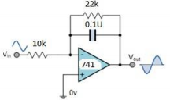

**Figure 2**

**PROCEDURE:**

1. Connect the components/equipment as shown in the circuit diagram Figure 2.
2. Switch ON the power supply.
3. Apply sine wave at the input terminals of the circuit using function Generator.
4. Connect channel-1 of CRO at the input terminals and channel-2 at the output terminals.
5. Observe the output of the circuit on the CRO which is a cosine wave (90o phase shifted from the sine wave input) and note down the position, the amplitude and the time period of Vin & Vo.
6. Now apply the square wave as input signal.
7. Observe the output of the circuit on the CRO which is a triangular wave and note down the position, the amplitude and the time period of Vin & Vo.
8. Plot the output voltages corresponding to sine and square wave inputs as shown in the Figure 3 below.

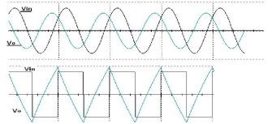

**Figure 3**

**CALCULATIONS:**

VO can be calculated by the following formula.

$$V_{o}=\frac{1}{R_{in}C_{f}}\int{V_{in}dt}$$

By putting given values in above formula, we get the results shown in table on the next page.

**OBSERVATIONS:**

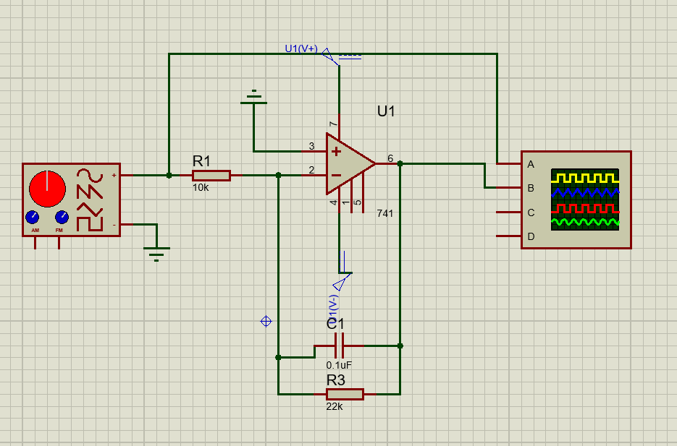

Op-Amp as an Integrator

|  |  |  |  |  |
| --- | --- | --- | --- | --- |
| **Vin(p-p)** | **Frequency** | **Vo (Theoretical)** | **Vo (Experimental)** | **%Error** |
| 1V | 1kHz | 0.1592 | 0.1607 | 1% |
| 2V | 1kHz | 0.3183 | 0.3201 | 0.55% |
| 1V | 2kHz | 0.0796 | 0.0832 | 4.6% |
| 2V | 1.5kHz | 0.2122 | 0.2147 | 1.19% |
| 2.5V | 2.5kHz | 0.1592 | 0.1641 | 3.11% |

**CONCLUSION:**

We conclude the following results from this experiment:

* **Op-amp Integrator** is an operational amplifier circuit that performs the mathematical operation of **Integration**
* By replacing this feedback resistance with a capacitor, we have an RC Network connected across the operational amplifiers feedback path producing another type of operational amplifier circuit commonly called an **Op-amp Integrator** circuit as shown below.